

Patent Proposed Application
Smartwatch-Based Alcohol Detection and Vehicle Ignition Prevention System
Anastasiia Igorevna Shaposhnikova – student at Amity University Tashkent.
Dr. Sudhanshu Tripathi – Associate professor at Amity University Tashkent, Head of Amity Innovation, Design and Research Center.

Summary
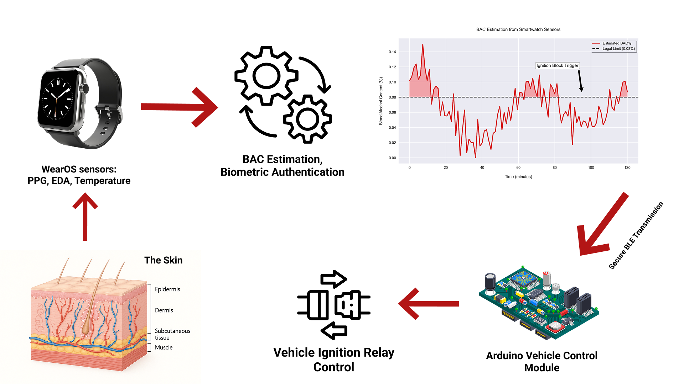
Smartwatch-Based Alcohol Detection and Vehicle Ignition Prevention System that integrates wearable biosensing technology with automotive control mechanisms via secure Bluetooth Low Energy (BLE) communication. The system continuously monitors the driver’s blood alcohol concentration (BAC) through transdermal and physiological sensors embedded in a Wear OS smartwatch. Upon detecting BAC levels exceeding legally permissible thresholds, the smartwatch transmits a real-time signal to an Arduino-based vehicle control module, which subsequently inhibits engine ignition to prevent impaired driving.
Key features
Key features include:
- Wear OS Sensor Fusion:
Utilization of multiple physiological metrics — such as photoplethysmography (PPG), electrodermal activity (EDA), and skin temperature — to estimate BAC with high accuracy, enhanced by adaptive calibration algorithms tailored for regional climate conditions (e.g., high temperatures in Central Asia).

- Secure BLE Communication:
Encrypted, low-latency data transfer between the smartwatch and vehicle control unit ensures timely and tamper-resistant transmission of alcohol detection status.
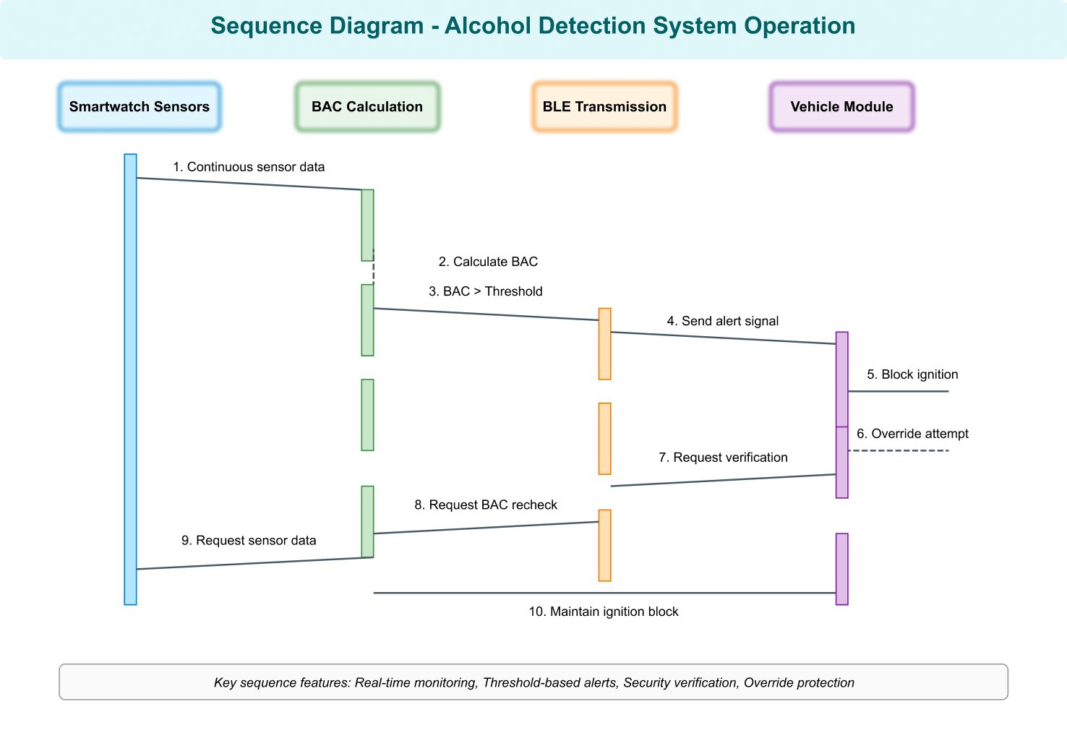
- Arduino-Based Ignition Control Module:
A modular, cost-effective hardware interface compatible with standard vehicle onboard diagnostics (OBD-II) systems, capable of interrupting ignition circuits based on received BAC data.

- Anti-Tamper and Authentication Protocols:
Continuous biometric verification to confirm the smartwatch is worn by the driver, preventing circumvention by unauthorized users or device removal.

- Simulation-Driven Development:
Use of Arduino enables rapid prototyping and testing of the ignition control logic and BLE communication.

Design
The system architecture comprises three primary components:

- Wear OS Smartwatch Application:
Developed using Kotlin with modern Android architecture components (Jetpack Compose, Dagger Hilt, Coroutines), the app continuously collects sensor data from the watch’s health APIs. A sensor fusion algorithm processes PPG, EDA, and temperature readings to estimate BAC dynamically. The application implements a secure BLE peripheral role, broadcasting encrypted BAC status updates to paired vehicle modules.
- Vehicle Control Module (Arduino-Based):
An Arduino-compatible microcontroller with BLE central capabilities receives BAC data. It interfaces with the vehicle’s ignition system via relay or OBD-II protocols to enable or disable engine start. The module includes fail-safe mechanisms and tamper detection sensors to ensure system integrity.
- Communication and Security Layer:
The BLE communication protocol incorporates AES-256 encryption and mutual authentication to prevent spoofing or replay attacks. The smartwatch authenticates the driver biometrically through continuous heart rate and motion pattern analysis, ensuring the system responds only when the authorized user is present.
- Climate-Adaptive Calibration Algorithm:
The BAC estimation algorithm adjusts sensor readings based on ambient temperature and humidity inputs, compensating for environmental factors that could affect sensor accuracy, a feature critical for deployment in regions with extreme climates such as Uzbekistan.

The design supports modular upgrades and integration with smartphone middleware for extended range and logging capabilities, enabling future scalability.

Analysis
Comparison with Existing Technologies:
- Unlike traditional ignition interlock devices that require breathalyzer input or dedicated hardware, this system utilizes existing smartwatch sensors, reducing hardware costs and improving user convenience.
- Prior patents focus on proprietary wearable devices or dashboard-mounted sensors; this invention uniquely leverages Wear OS platforms and off-the-shelf Arduino modules, enabling rapid development and broad compatibility.
- The climate-adaptive calibration algorithm addresses a significant gap in current research, as existing systems largely ignore environmental impacts on sensor accuracy, which can lead to false positives or negatives.
- Security protocols exceed typical BLE implementations by combining biometric authentication and encrypted communication tailored for automotive safety standards, mitigating risks of tampering or unauthorized overrides.

Literature Review
- Fairbairn, C. E., & Kang, D. (2021). Transdermal alcohol monitors: Research, applications, and future directions (pp. 551–562). Academic Press. https://doi.org/10.1016/B978-0-12-816720-5.00014-1

- Das, D. K., Reddy, A. P., Ajay, ADD. S. K., Dhanalakshmi, D., Hariharan, S., & Kukreja, V. (2023). Vehicle Ignition Locking System and Analysis for Accident Prevention by Blood Alcohol Content Measurement. 1494–1499. https://doi.org/10.1109/icssas57918.2023.10331684

- Lombardo, L., Grassini, S., Parvis, M., Donato, N., & Gullino, A. (2020). Ethanol breath measuring system. IEEE International Symposium on Medical Measurements and Applications, 1–6. https://doi.org/10.1109/MEMEA49120.2020.9137215

- "Wearable alcohol monitoring system with vehicular interface" https://www.mdpi.com/1424-8220/24/13/4233#
- P. Vergés et al., "Smartwatch-Based Prediction of Transdermal Alcohol Levels Using Hyperdimensional Computing," 2024 IEEE 10th World Forum on Internet of Things (WF-IoT), Ottawa, ON, Canada, 2024, pp. 1-6, 10.1109/WF-IoT62078.2024.10811151
- Vehicle and Driver Monitoring System Using On-Board and Remote Sensors
https://www.mdpi.com/1424-8220/23/2/814

Smartwatch-Based Ecological Momentary Assessment for High-Temporal-Density, Longitudinal Measurement of Alcohol Use (AlcoWatch): Feasibility Evaluation

https://formative.jmir.org/2025/1/e63184/

